TO: All Club Secretaries

FROM: BMXNSW State Coaching Director

2018 BMXNSW COACH OF THE YEAR AWARD
Melissa Chambers
BMXNSW Executive Director

2018 will see the continuation of the BMXNSW Coaches recognition program. One award will be presented to the ‘Coach of the Year’. This annual award, open to both male and female accredited coaches, recognises the valuable contribution our coaches provide to the development of the sport and the riders.

Please find attached the selection criteria and a nomination form. All Clubs are encouraged to nominate the Coach they think meets or exceeds the criteria.

The award for the ‘Coach of the Year’ will be presented at the BMXNSW Awards night, Friday 28 September 2018 at Castle Hill RSL.

Nominations for this award close on Sunday, 02 September 2018. Nominations are to be sent to
bmxnsw.executivedirector@gmail.com.

Yours sincerely

Melissa Chambers
BMXNSW Executive Director

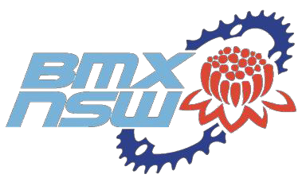

SELECTION CRITERIA - 2018 BMX NSW COACH OF THE YEAR

The purpose of the Coach of the Year award is to give some recognition to the coaches who help develop the sport of BMX racing.

Please answer the following selection criteria in detail. The more information you supply the better.

- How does the nominated Coach demonstrate and present a positive role model?
- Does the nominated Coach conduct or take part in Club or State coaching programs, or assist individual riders with their development?
- Has the nominated Coach had any success with athlete results? ie Have the coached athletes shown marked improvement? If so, please give examples (You don’t have to be a world beater to show improvement)
- How does the nominated Coach promote the Sport of BMX?
- How does the nominated Coach assist with the development of Club coaching?
- What age group is the Coach involved with?
- Can the Coach work with Male & Female athletes? Give examples.
- Any other information you think may be relevant.

Email nominations to: bmxnsw.executivedirector@gmail.com

Please Note:

Closing date for nominations is Sunday, 02 September 2018. Nominations can be made by any person but should come via a Club.

Your Club CAN nominate more than one Coach.

NOMINEE
Nomination Form
2018 BMXNSW Coach of the Year

Name of Coach Being Nominated
Contact No’s.
Email Address

NOMINATED BY

Name of Nominating Person/Club
Contact No’s.
Email Address

SELECTION CRITERIA RESPONSES

